**A**

**PROJECT REPORT**

ON

**Mental Health Mate**

Submitted in partial fulfillment for the award of

**Post Graduate Diploma in Advance Computing**

**(PG-DAC) from**

**INSTITUTE OF EMERGING TECHNOLOGIES**

**Authorized Training Centre**



**Under the Guidance of**

**Prof. Saleel Bagade**

**BY**

Anisha Malode : 230345920015

Rohit Srivastava : 230345920076

Tejas Ruikar : 230345920077

Sanskruti Mankar : 230345920089



**CERTIFICATE**

This is to certify that the project report entitled **Mental Health Mate** is a bonfire work carried out by **ANISHA MALODE, ROHIT SRIVASTAVA, TEJAS RUIKAR, and SANSKRUTI MANKAR** andsubmitted in partial fulfillment ofthe requirement for the C-DAC ACTS, DAC course in Institute of Emerging Technology in the batch of MARCH 2023.

**Course Coordinator** **External Examiner**

**ACKNOWLEDGEMENT**

This project **Mental Health Mate** was a great learning experience for us and we are submitting this work to Advanced Computing Training School (CDAC).

We are very glad to mention Prof. Saleel Bagade for her valuableguidance to work on this project. Her guidance and support helped us to overcome various obstacles and intricacies during the course of project work.

Our most heart full thanks go to ***Mr. Sangram Patil*** **(Director, IET)**who gave all the required support and kind coordination to provide all the necessities like required hardware, internet facility, and extra lab hours to complete the project and throughout the course up to the last day here in C-DAC ACTS, Pune.

Sign of students

**Anisha Malode (230345920015)**

**Rohit Srivastava (230345920076)**

**Tejas Ruikar (230345920077)**

**Sanskruti Mankar (230345920089)**

**Abstract**

The "Mental Health Mate" web application is a groundbreaking platform designed to address the pressing challenges of mental health support and awareness in today's society. With a focus on promoting emotional well-being, providing accessible resources, and fostering a sense of community, Mental Health Mate offers users a comprehensive toolset to navigate their mental health journeys. Through a user-friendly interface, individuals can access a variety of features including educational content, self-assessment tools, guided meditation sessions, and a supportive community forum. By harnessing the power of technology, Mental Health Mate aims to bridge the gap between individuals seeking mental health assistance and the resources they need, ultimately contributing to a more informed, resilient, and connected global population.

**Index**

|  |  |  |
| --- | --- | --- |
| **Sr. No.** | **Title** | **Page No.** |
| **1** | Introduction | 6 |
| **2** | Problem Definition & Scope | 7 |
| **2.1** | Problem Definition | 7 |
| **2.2** | Goals & Objectives | 8 |
| **2.3** | Major Constraints& Outcomes | 9 |
| **3** | Software Requirement Specification | 10 |
| **3.1** | Purpose | 10 |
| **3.2** | Scope | 10 |
| **3.3** | Functional & Non-functional Requirements | 11 |
| **4** | System Modules | 13 |
| **5** | Performance-Requirements | 14 |
| **5.1** | H/W Requirements & S/W Requirements | 14 |
| **6** | UML Diagram | 15 |
| **6.1** | DFD |  |
| **6.2** | ERD |  |
| **6.3** | Use case diagram |  |
| **6.4** | Class Diagram |  |
| **6.5** | Sequence diagram |  |
| **6.6** | Activity Diagram |  |
| **6.7** | Deployment diagram |  |
| 6.8 | System Architecture |  |
| **7** | Test Cases |  |
| **8** | Application Screenshots |  |
| **9** | Future Scope |  |
| **10** | References |  |

1. **Introduction**

In recent years, the importance of mental health has gained significant recognition as a critical component of overall well-being. The modern world's fast-paced nature, coupled with various life stressors, has led to a rise in mental health challenges such as anxiety, depression, and stress-related disorders. However, while awareness surrounding mental health has improved, there remains a substantial gap between the demand for support and the accessibility of appropriate resources. The advent of technology provides an unprecedented opportunity to address this gap.

The "Mental Health Mate" web application emerges as a response to this pressing need for accessible and comprehensive mental health support. This platform goes beyond the traditional confines of therapy and counseling by offering a diverse range of tools tailored to individual preferences and needs. The application's user-centric design prioritizes ease of use and inclusivity, ensuring that individuals of all ages and technological backgrounds can benefit.

This project outlines the fundamental features and objectives of the Mental Health Mate web application. We delve into the various components that make up the platform, including its educational resources, self-assessment tools, guided meditation sessions, and community forum. Additionally, we explore the potential impact of such a platform on individuals seeking mental health assistance and the broader societal implications of promoting emotional well-being through digital means. Through the convergence of technology, mental health expertise, and community engagement, Mental Health Mate strives to revolutionize the way society approaches, discusses, and supports mental health challenges.

Top of Form

1. **Problem Definition and Scope**
   1. *Problem Definition*

The contemporary world is grappling with a multifaceted mental health crisis, characterized by rising rates of anxiety, depression, and other emotional disorders. Despite growing awareness surrounding mental health, significant barriers prevent individuals from accessing timely and effective support. These barriers encompass social stigma, limited access to mental health professionals, lack of knowledge about available resources, and challenges in maintaining consistent self-care practices. This confluence of factors creates an urgent need for a comprehensive and accessible solution that addresses these barriers and empowers individuals to proactively manage their mental well-being.

The "Mental Health Mate" web application emerges to tackle these pressing challenges. It recognizes that a substantial percentage of the population seeks assistance outside of traditional clinical settings, demanding a flexible and technologically-driven approach to mental health support. By offering a user-friendly interface and an array of features, Mental Health Mate aims to bridge the gap between individuals in need and the resources that can contribute to their emotional well-being. This problem statement encompasses the following key aspects:

* **Limited Accessibility:** Many individuals face challenges in accessing mental health services due to factors such as geographical location, financial constraints, and long waiting times. This lack of accessibility exacerbates mental health issues and prevents timely interventions.
* **Stigma and Awareness:** Social stigma continues to surround mental health, deterring individuals from seeking help and openly discussing their struggles. Additionally, there is a lack of awareness about available resources and coping strategies that can aid in managing mental health.
* **Personalized Support:** The one-size-fits-all approach to mental health support often falls short in addressing the diverse and unique needs of individuals. Customized and personalized interventions are essential for effective management and recovery.
* **Consistency and Engagement:** Maintaining consistent self-care practices is challenging for many. Individuals often struggle to stay engaged with mental health routines and may benefit from tools that foster motivation and accountability.
* **Isolation and Community:** Mental health challenges can lead to feelings of isolation. Building a supportive community can alleviate this isolation, providing a sense of belonging, understanding, and shared experiences.

Addressing these issues requires a dynamic and adaptable solution that harnesses the power of technology. The Mental Health Mate web application seeks to provide a holistic support system, guiding users through their mental health journeys with education, assessment, mindfulness practices, and community interaction. By recognizing the nuanced nature of the problem and tailoring its approach to individual needs, Mental Health Mate aims to revolutionize the way society approaches mental health support and contribute to a more informed, empathetic, and resilient global community.

Top of Form

* 1. *Goals and objectives*

**Goals:**

* **Promote Mental Well-being:** The primary goal of the Mental Health Mate web application is to promote and enhance mental well-being among its users by providing accessible and comprehensive resources.
* **Reduce Stigma:** The application aims to reduce the stigma associated with mental health by fostering open conversations and creating a supportive community where users can share their experiences without fear of judgment.
* **Empower Self-Care:** The application seeks to empower users with the tools and knowledge to take control of their mental health through self-care practices, guided meditation, and educational resources.
* **Increase Awareness:** Mental Health Mate aims to increase awareness about various mental health conditions, coping strategies, and available resources, fostering a more informed user base.
* **Facilitate Connection:** The application strives to create a sense of connection and belonging among users through its community forum, enabling individuals to connect with others who share similar experiences.
* **Provide Personalized Support:** Mental Health Mate aims to offer personalized support by tailoring content, resources, and recommendations to each user's unique needs and preferences.

**Objectives:**

* **Educational Empowerment:** Develop a comprehensive library of educational articles, videos, and resources on various mental health topics. Offer easily understandable content that helps users increase their mental health literacy.
* **User Engagement:** Encourage regular engagement by providing goal-setting features, progress tracking, and personalized notifications. Implement gamification elements to motivate users to consistently use the application.
* **Holistic Support:** Provide a range of self-assessment tools to help users evaluate their mental well-being and receive tailored recommendations. Offer guided meditation sessions and relaxation exercises to facilitate stress reduction and emotional regulation.
* **Community Building:** Create a safe and inclusive community forum where users can share their experiences, seek advice, and provide support to others. Implement moderation tools to ensure respectful interactions and a positive environment.
* **Personalization**: Utilize user profile data, assessment results, and interaction history to offer personalized content recommendations. Allow users to set and track their mental health goals, with the application providing relevant resources and reminders.
* **Accessibility and Usability:** Ensure the application's user interface is intuitive, easy to navigate, and accessible to individuals with disabilities. Design responsive layouts that work seamlessly across various devices and screen sizes.
* **Data Privacy and Security:** Implement robust security measures to protect user data and ensure compliance with data protection regulations. Provide clear privacy policies and give users control over the data they share.
* **Awareness and Education:** Collaborate with mental health professionals and organizations to ensure the accuracy and relevance of educational content. Run awareness campaigns and initiatives to increase knowledge about mental health issues and reduce stigma.
* **Continuous Improvement:** Regularly gather user feedback to identify areas for improvement and new features. Implement updates and enhancements based on user suggestions and evolving mental health trends.
* By achieving these goals and objectives, the Mental Health Mate web application aspires to create a positive impact on users' mental well-being, empower them with the tools for self-care, and contribute to a more compassionate and informed society
  1. *Major Constrains and Outcomes*

**Constraints:**

* **Privacy and Security:** Mental health data is sensitive, and the application must adhere to strict privacy regulations and ensure data security to protect users' personal information.
* **Accessibility:** Ensuring that the website is accessible to all users, including those with disabilities, is essential for an inclusive experience.
* **Medical Accuracy:** Any medical advice or information provided on the platform must be accurate and backed by reliable sources to prevent misguidance.
* **User Vulnerability:** Users of mental health applications might be in vulnerable states. The platform needs to be designed with empathy, avoiding triggering content, and providing appropriate support.
* **Integration with Mental Health Professionals:** If the application offers interaction with mental health professionals, it must establish a reliable and secure communication platform.
* **Limited Self-Diagnosis:** The platform should discourage users from self-diagnosing or self-treating serious mental health conditions and should encourage seeking professional help.

**Outcomes:**

* **Increased Awareness:** The application can help raise awareness about mental health issues, reduce stigma, and promote open conversations.
* **Access to Resources:** Users can access a range of resources including articles, self-help tools, coping strategies, and more.
* **Supportive Community:** An online community within the platform can provide users with a safe space to share experiences, provide mutual support, and combat feelings of isolation.
* **Professional Assistance:** If integrated, the app can connect users with licensed mental health professionals, offering online therapy or counseling.
* **Monitoring and Tracking:** Some applications might allow users to track their mood, progress, or triggers, providing insights and aiding in self-awareness.
* **Education:** Users can learn about different mental health conditions, their symptoms, and available treatments, helping them make informed decisions.
* **Reduced Social Isolation:** The community features can reduce feelings of loneliness by connecting individuals who share similar experiences.
* **Feedback and Improvement:** User engagement and feedback can help improve the application over time, making it more effective in supporting mental health.

1. **Software Requirement Specifications**
   1. *Purpose*

The aim of the "Mental Health Mate" web application is to create a holistic and compassionate online platform that addresses the diverse needs of individuals dealing with mental health challenges. By leveraging technology and psychological expertise, the application strives to achieve the following objective:

To design and develop a complete mental health care and support package in a single platform for the general public. This system should provide fast and responsive health care and support solutions to users with easy access. It should provide Self-assessment questionnaires to gauge mental well-being. A distinguishing feature of the application lies in its ability to bridge the gap between individuals and mental health professionals.

The "Mental Health Mate" application is not only a resource hub but also a catalyst for change. By promoting mental health awareness, reducing stigma, and advocating for early intervention, the application contributes to a broader movement of destigmatizing mental health issues. With a commitment to user privacy, data security, and ethical guidelines, the application seeks to ensure a safe and responsible digital environment for individuals seeking support.

* 1. *Scope*
* **Target Audience:**

Individuals seek information, resources, and tools related to mental health. Those in need of self-help strategies and coping techniques. Individuals interested in connecting with licensed mental health professionals for online therapy

* **Features and Functionalities:**

The "Mental Health Mate" web application offers a diverse range of features and functionalities to cater to individuals seeking mental health support and resources. Users can access a comprehensive library of educational materials, including articles, and infographics, providing accurate insights into various mental health conditions and treatment options. The application empowers users with self-assessment tools, allowing them to gauge their mental well-being and track progress over time through questionnaires. A unique facet of the application is its seamless connection to licensed mental health professionals, enabling users to schedule online therapy appointments and engage in personalized guidance and support. Within the platform's online community, users can participate in discussion forums and support groups, fostering a sense of belonging and offering a safe space to share experiences. The application tailors content recommendations based on individual preferences and assessment results, ensuring users receive personalized guidance. With the integration of payment gateways, users can conveniently make payments for professional services, while stringent security measures and adherence to data protection regulations maintain user privacy and confidentiality. The "Mental Health Mate" web application is built on ethical considerations, promoting responsible content sharing, accurate information dissemination, and respect for user privacy. This platform seeks to bridge the gap between mental health awareness and professional support, offering users a versatile and user-centric tool to enhance mental well-being, foster connections, and navigate the complexities of mental health with confidence and resilience and help the user maintain their medical history and reports on medications provided by professional support on a single platform.

*Functional & Non-functional Requirements*

**Functional requirements**

The "Mental Health Mate" web application is envisioned as a comprehensive platform that offers a wide range of functional features to cater to the mental health needs of its users. These functional requirements are carefully designed to ensure that the application effectively addresses the diverse challenges individuals face in managing their mental well-being. The following points outline the key functional requirements of the application.

**Admin Dashboard:** To manage user accounts, content, and overall platform operations, administrators will have access to a comprehensive admin dashboard. This dashboard will empower administrators to monitor user activities, moderate user-generated content, and manage professional profiles.

**User Authentication and Profiles:** The application will provide a user-friendly registration and login system, enabling users to create accounts with their personal information. Different user roles will be implemented, including regular users, licensed mental health professionals, and administrators. Each user will have a profile page where they can manage their account settings, preferences, and additional details. User authentication will employ secure methods to protect sensitive information.

**Education and Resources:** To promote mental health awareness, the application will feature an extensive repository of educational materials. Users will be able to access articles, infographics, and other resources related to various mental health conditions, treatments, coping strategies, and self-care techniques.

**Self-Assessment and Tracking:** The application will facilitate self-assessment of mental well-being through interactive questionnaires designed to gauge emotional states, stress levels, and potential symptoms. The data collected will be visually presented in graphs and charts, allowing users to identify patterns and trends in their emotional states.

**Professional Interaction:** To bridge the gap between users and mental health professionals, the application will offer a platform for booking online therapy appointments. Users can browse profiles of licensed therapists and counselors, view their specialties, and select professionals based on their preferences.

**Medical History:** The application will enhance user experience by providing personalized content recommendations. Based on user preferences, assessment results, and browsing history, the application will suggest relevant resources, articles, and videos. Users will also have the ability to save and bookmark their favorite resources for future reference.

**Payment and Billing:** For users seeking professional assistance, the application will integrate secure payment gateways. Users can make payments for online therapy sessions and services, and the application will generate invoices and receipts for transaction records. This feature ensures a seamless and convenient process for users accessing professional help.

**Data Security and Privacy:** Security will be a paramount concern in the application's design. User data will be encrypted and protected using robust security measures. Additionally, users will have control over their privacy settings, allowing them to manage data sharing preferences and determine the level of information they wish to disclose.

**Reporting and Analytics:** Administrators will have access to a dedicated dashboard that provides insights into platform usage, user engagement, and content performance. Usage reports and aggregated data, stripped of personal identifiers to ensure privacy, will also be available for research purposes, contributing to the understanding of mental health trends and needs.

**Non-functional requirements for Mental Health Mate Web Application:**

The following non-functional requirements are considered below:

* Usability and reliability
* Security
* Scalability
* Compatibility
* Maintenance
* Compliance
* Other

1. The system should be easy to use, intuitive, and user-friendly for users who may not have technical skills it should be highly reliable, with minimal downtime or system failures. It should be able to handle unexpected situations or issues with minimal disruption to the organization's activities. The system should be reliable and available 24/7 to provide support and assistance to visiting users.
2. The system should be secure, with appropriate measures to protect sensitive data and prevent unauthorized access or use of the system. It should secure and protect sensitive information such as medical history and personal data of users.
3. System should be scalable enough to handle increasing demand and changing requirements, such as the ability to handle more users, doctors, and other. The system should perform well, providing fast and accurate responses to user requests.
4. The system should be compatible with various devices and platforms, ensuring that users can access it from different devices such as smartphones, tablets, and laptops. The system should be easy to maintain, update, and upgrade when necessary.
5. The system should comply with relevant laws, regulations, and standards in the healthcare and technology industries.
6. Other considerations such as marketing and promotion, peer group provision for users, and collaboration with doctors and other mental health care support organizations.
7. **System Modules**

* **Admin and Moderation:**
  + Admin dashboard for managing users, content, and interactions
  + Quality control and ensuring adherence to guidelines
* **User Authentication and Management:**
  + User registration and login
  + User profile management
* **Doctor Authentication and Management:** 
  + Doctor registration and login
  + Doctor profile management
* **Information and Education:**
  + Articles and resources on mental health topics
  + FAQs and information about various mental health conditions
* **Self-Assessment and Surveys:**
  + Self-assessment questionnaires to gauge mental well-being
  + Generating assessment reports and insights
  + Tailored self-help resources based on assessment results
* **Professional Assistance:**
  + Connecting users with licensed therapists and counselors
  + Customized medical health card based on user medications and medical history
* **Appointment Scheduling:**
  + Booking appointments with mental health professionals
  + Availability of slots for professionals
* **Payment and Billing:**
  + Handling payments for professional services
  + Secure payment gateways and transaction history
  + Billing and invoices for services rendered
* **Analytics and Reporting:**
  + Generate reports for users and professionals
  + Aggregate user data for diagnosis and medications
* **Feedback and Improvement:**
  + User feedback collection and surveys
  + Continuous improvement based on user input

1. **Performance Requirement**
   1. Hardware Requirements

* CPU: Multi-core processor (e.g., Intel Xeon, AMD Ryzen) for handling concurrent user requests.
* RAM: Minimum 8 GB of RAM for small to moderate traffic; 16 GB or more for higher traffic loads.
* Storage: SSD for faster data access and improved application performance.
* Network: High-speed internet connection with sufficient bandwidth to handle incoming and outgoing data traffic.
  1. Software Requirements

1. **UML Diagrams**
   1. Data Flow Diagram (DFD)

* Zero level:

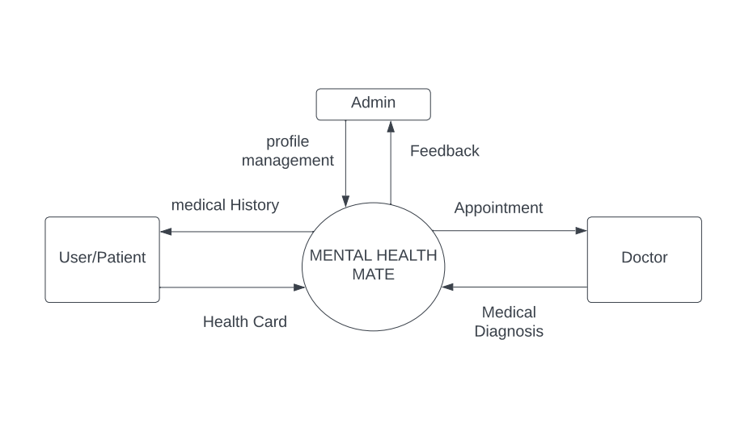

* First level:

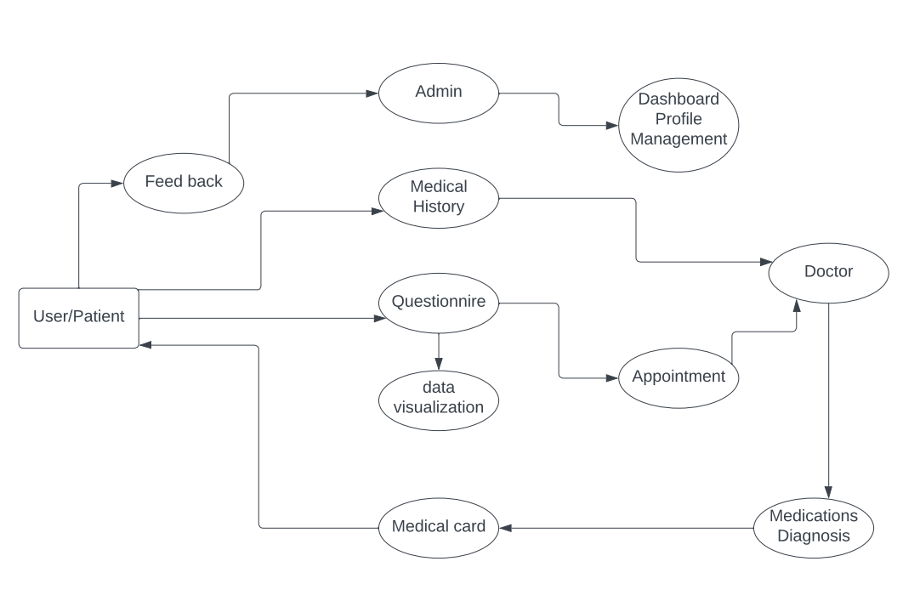

* 1. Entity Relationship Diagram (ERD)
  2. Use Case Diagram

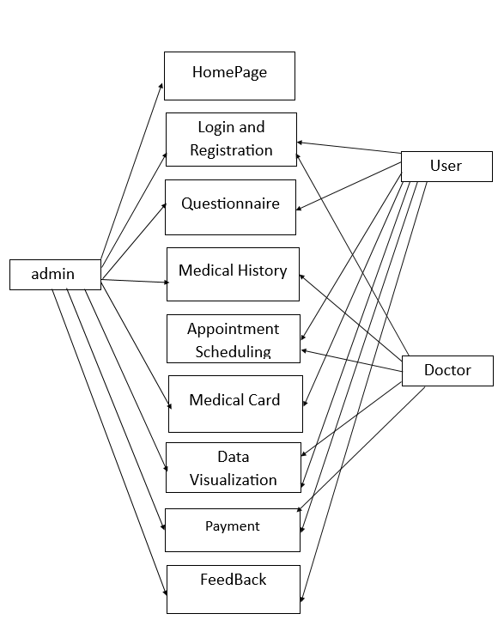

* + Class Diagram

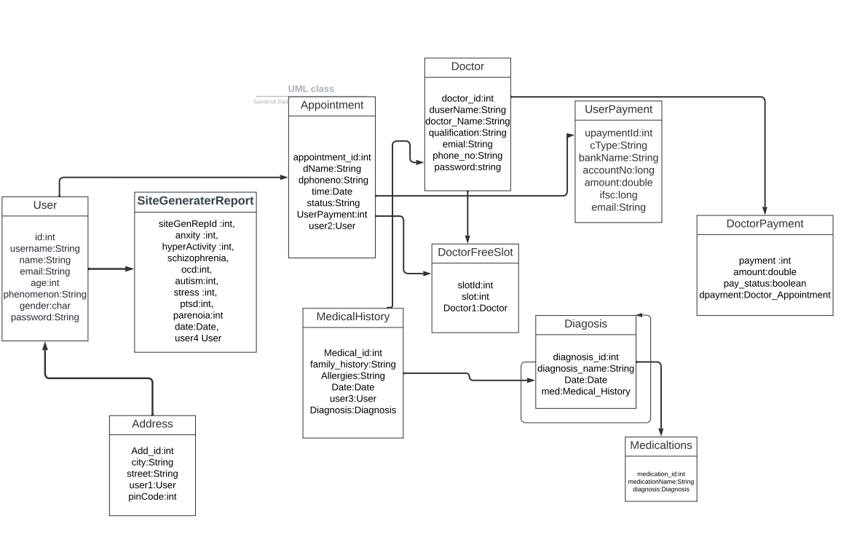

* + Deployment Diagram

1. **Test Cases**
2. **Application Screenshots**
3. **Future Scope**
4. **References**